

Lab Report: 02
Course code:
CSE 2104
Course title: Object Oriented Programming Lab
Experiment Title: Implementation of Class and Object Variables with Parameterized Constructor in Java

Submitted by:
Name: Shafin Mehrab
ID: 251014058
Department: (CSE)

Submitted to:
Name: Fatema Khan
Lecturer, University of Liberal Arts Bangladesh

Contents
 | Page
Experiment Objectives | 2
Problem Statement | 2
Concepts and Background | 2
Functional Requirements and Designs | 3
Constraints and Assumptions | 7
Implementation | 8
Discussion | 9
Conclusion | 9
References | 9

Experiment Objectives:
- Design a user-defined Java class structured with distinct object and class attributes.
- Implement a parameterized constructor to initialize individual object states directly upon creation.
- Demonstrate data input via Scanner without using complex structures or advanced loops.
- Run a method to print both the student’s own info and the shared university name to ensure they are kept separate.

Problem Statement:
Construct a Student class containing instance properties (id, name, department, cgpa) and a static class-level property (university). Use a parameterized constructor to initialize three distinct Student instances sequentially using data received via user input, and provide an object method to print the student profile to the standard output.

Concepts and Background
- Class and Object: A class acts as a template defining attributes and behavior, whereas an object is an independent concrete instance created in heap memory with distinct state storage.
- Instance Variables: Fields declared inside a class without the static modifier. Each instance objects maintains its own private copy of these variables, meaning changes made to one object do not alter the values stored in another.
- Class (Static) Variables: Fields declared with the ‘static’ keyword. Exactly one copy exists in class-level memory regardless of how many instances are created, making it the appropriate choice for shared attributes like institutional affiliations.
- Parameterized Constructor: A specialized method sharing the class name, lacking a return type, and accepting arguments. It runs at instantiation (new), binding initial values directly into instance variables so objects never exist in an uninitialized state.
- Input Handling (Scanner): When using Scanner.nextDouble(), Java consumes the numerical token but leaves the trailing newline character (\n) in the stream. A subsequent call to Scanner.nextLine() must be issued to consume this trailing delimiter before reading subsequent string lines.

Functional Requirements and Designs:
FR-1 | Prompt the console user to provide id, name, department, and cgpa for three individual students.
FR-2 | Pass inputs directly to a parameterized constructor to instantiate three separate objects.
FR-3 | Bind a single static string (university) across all objects.
FR-4 | Execute an object method (displayDetails()) that outputs all four instance variables alongside the class variable

Constraints and Assumptions:
- Console-only interaction via terminal streams (System.in, System.out).
- Implementation must avoid complex collections, arrays, and advanced loops, keeping execution strictly sequential.
- Assuming input values are assumed well-formed (valid numeric entry for CGPA).
Program Flow:
- Initialize the Scanner targeting standard input.
- Read id1, name1, dept1, and cgpa1; flush the trailing newline via ‘sc.nextLine()’.
- Call ‘new Student(id1, name1, dept1, cgpa1)’ and store the reference in s1.
- Repeat steps 2 and 3 for student references s2 and s3.
- Invoke s1.displayDetails(), s2.displayDetails(), and s3.displayDetails() sequentially.
- Close the scanner resource and terminate execution.
Implementation:
The report comes with a zip folder containing the source file (student.java) and that the program is written without using arrays. Each student's information is taken from the user one by one and passed straight into the constructor. An extra sc.nextLine() is used after nextDouble() to clear the enter key from the input buffer.

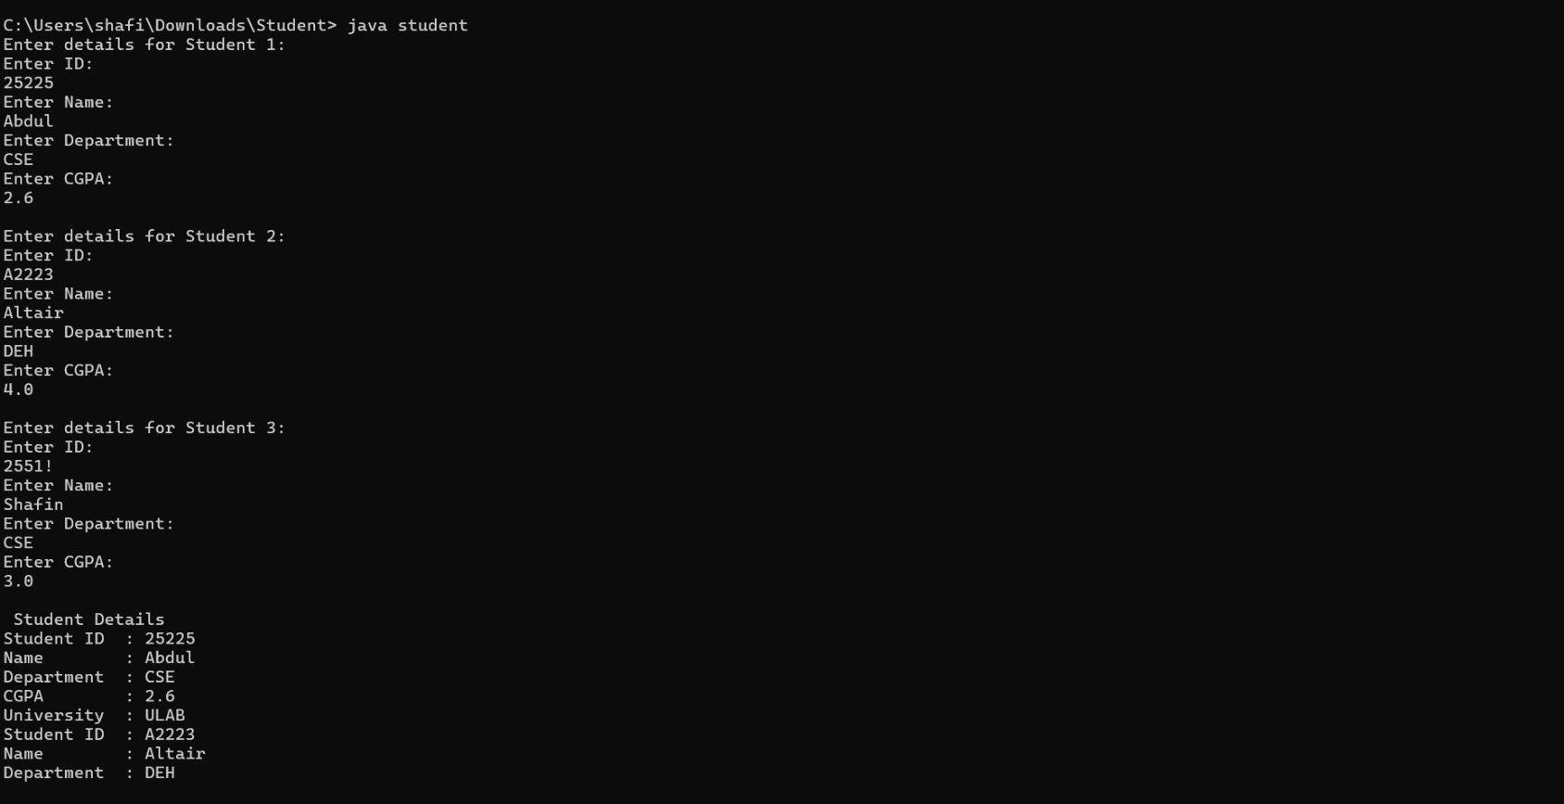
Output:

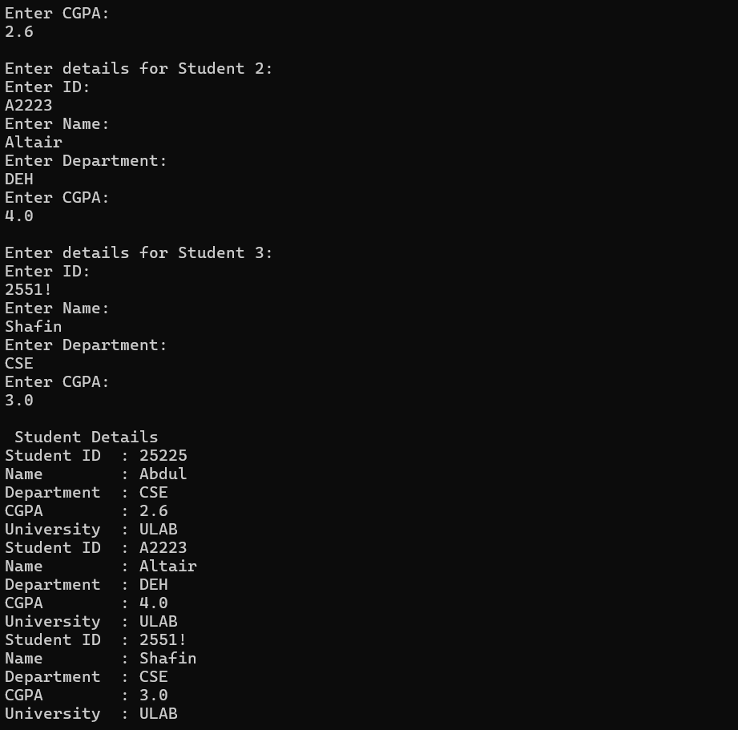

Result and Discussion.
The implementation fulfilled all functional requirements without any issues. As mentioned in program flow, the program collected interactive inputs and printed them in an orderly fashion.
By defining university as a static class member, the attribute belongs to the class namespace rather than individual instances, avoiding redundant memory allocation. Concurrently, independent instance variables ensured that s1, s2, and s3 preserved their distinct identities without variable collisions.
However, one issue I faced while testing was with taking user input. After typing the CGPA and pressing enter, sc.nextDouble() only took the number and left the enter key behind in the input buffer. Because of this, the program skipped the ID input for the next student. I fixed it by putting an extra sc.nextLine() right after reading each CGPA to clear that newline, and after that, all the inputs worked properly in order.
Conclusion and Reflection:
All primary lab objectives were met: a user-defined Java class was designed with distinct object and class attributes, instantiated through a parameterized constructor, and verified via console output. The experiment reinforced core Object-Oriented principles, notably the distinction between instance state and class-level static allocation. While the current design is straightforward and readable, future iterations could incorporate defensive validation against negative CGPA entries or reorganize multiple student instances into scalable collections.

Reference:
- Oracle. (2024). Classes and Objects (The Java™ Tutorials). Oracle Documentation.
- Oracle. (2024). Scanner (Java SE 17 & JDK 17). Oracle Documentation.

